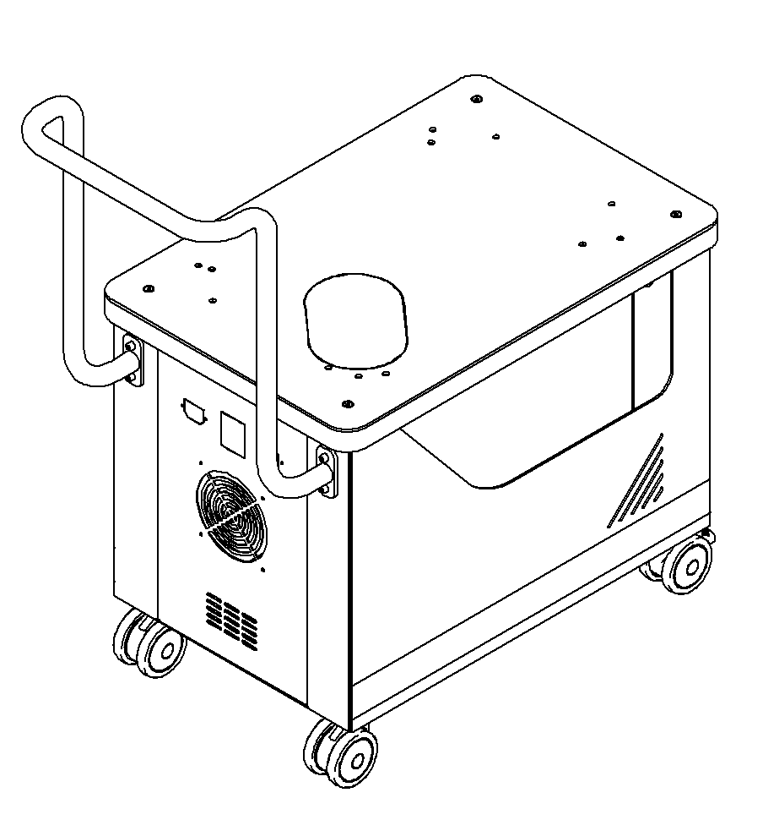

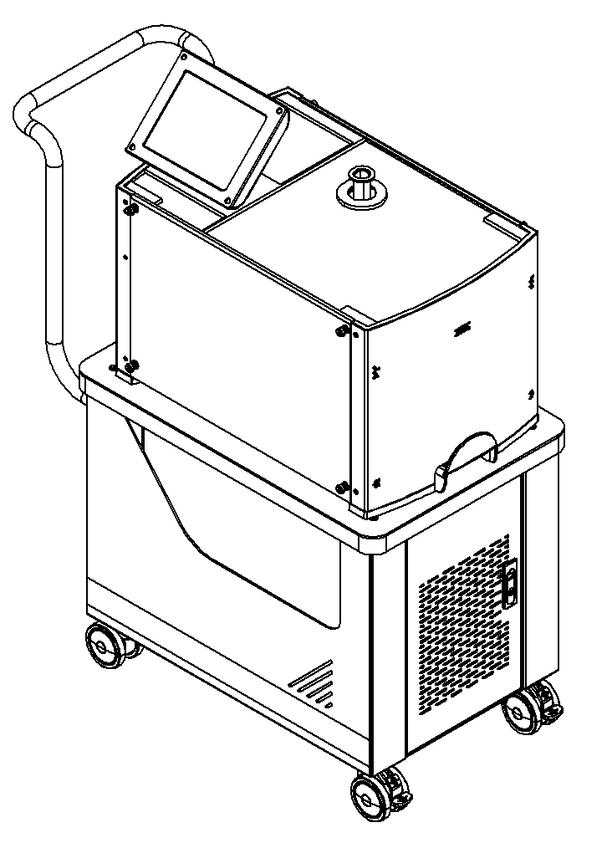

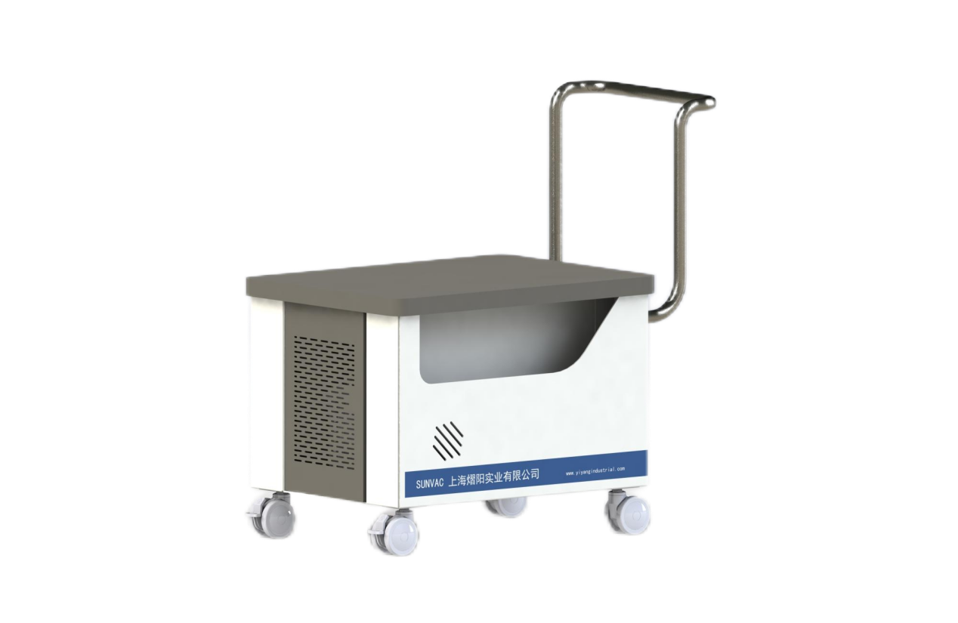

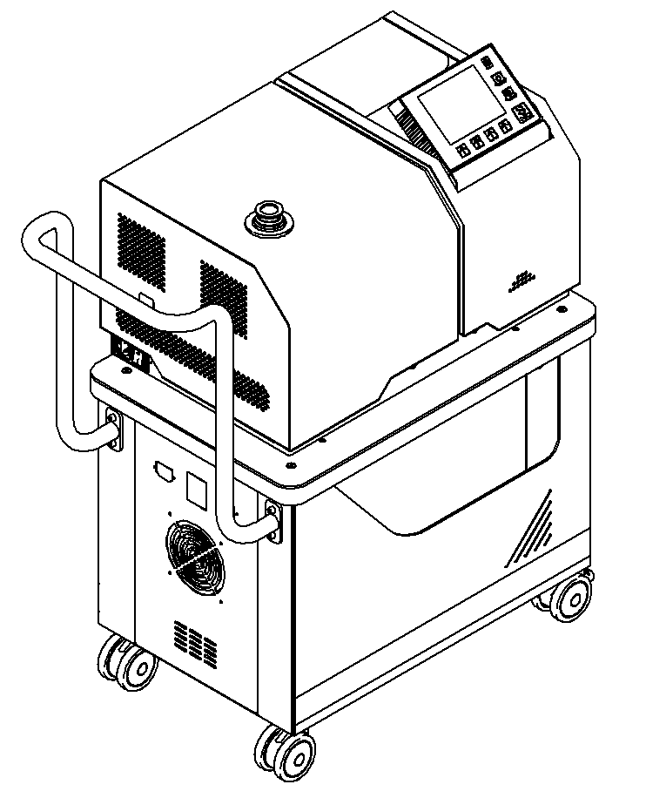

**Leak Detector Trolley User Manual**

Date of revision：2024.11

上海熠阳实业有限公司

www.yiyangindustrial.com

Table of contents

Introduction 1

Appearance Dimensions 1

Parts Desription 2

Assembly Instructions 2

Accessories 4

Transport Instructions 4

**Introduction**

The trolley is a special trolley for double-layer movable leak detector, the upper layer is placed with a leak detector, the lower layer is placed with a vacuum pump, and there is a certain storage space at the bottom. The bottom silent universal wheels can be moved flexibly, and the brake latch can smoothly fix the trolley to the desired place. Reserved electrical wiring ports allow for easy expansion of power supplies and cooling fans. Strong load capacity, can load 200Kg.

**Specifications**

|  |  |  |
| --- | --- | --- |
| Model and specifications | PTC-Ⅰ | Remark |
| Applicable Leak Detector | Agilent PD03, Pfeiffer ASM340, YIYANG SV280, etc |  |
| Applicable Vacuum Pump | DRV-16, DRV-24, ISP-500C , etc |  |
| Material | Q235 |  |
| Weight | 36Kg | curb weight |
| Incoming Power Supply | AC220V | reserved electrical interface |

***Note: Some machines need to be equipped with holes by the user.***

**Appearance Dimensions**

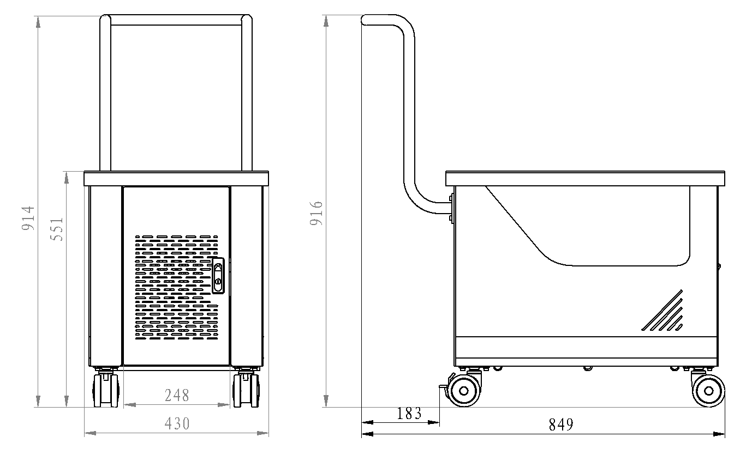

***Note: The size unit is "mm"***

**Part Description**

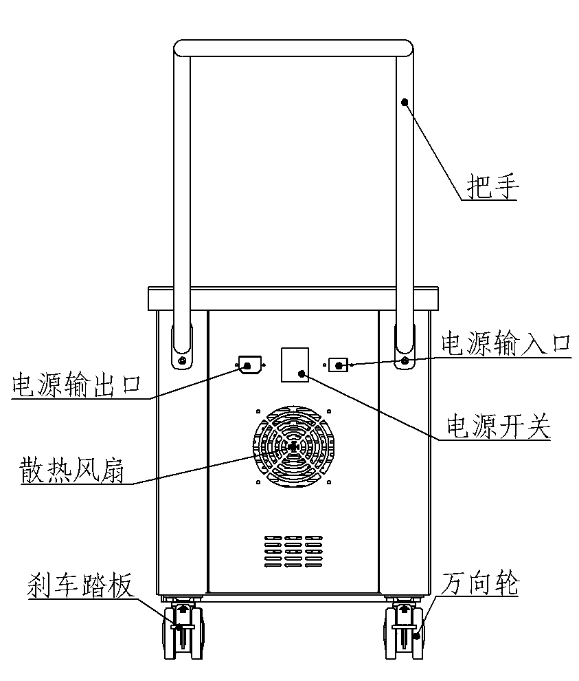

Handle

Power input port

Power Switch

Universal Wheel

Brake pedal

Cooling Fan

Power Output Port

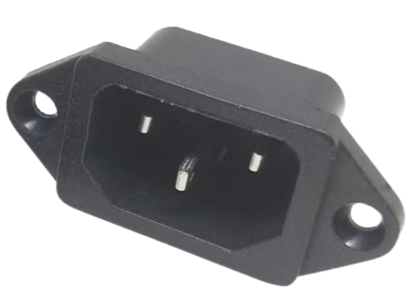

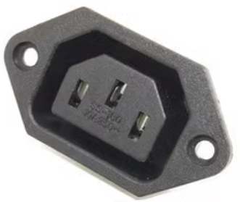

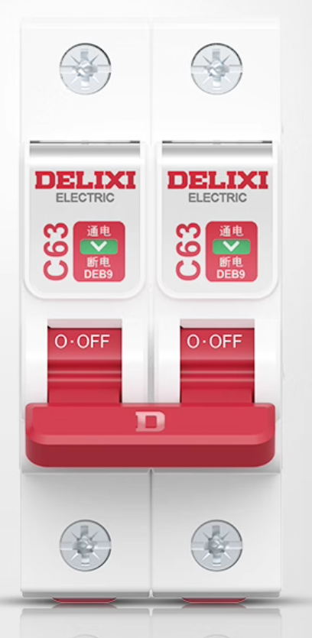

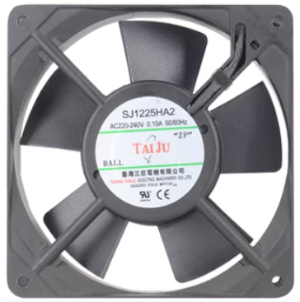

Note: All electrical accessories must be selected by the user according to application requirements. Specific specifications and parameters are provided in the attachment.

**Assembly Instructions**

Refer to the diagram below for the disassembly and assembly steps of each trolley component. For example, if installing a larger-sized scroll pump, remove component number 3.

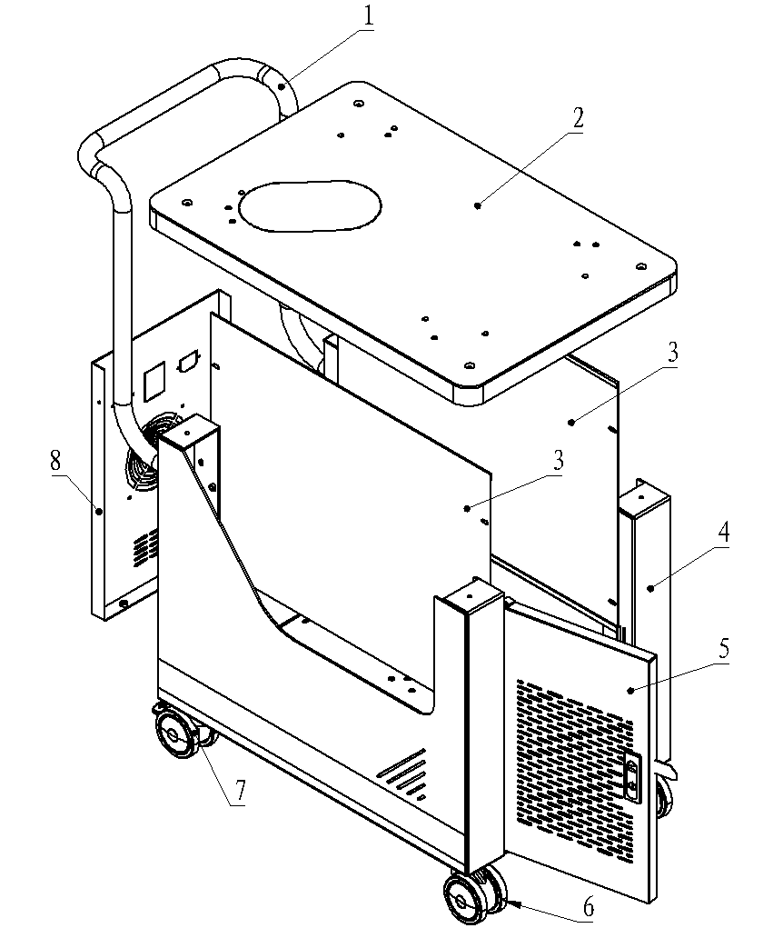

Tools：

hexagon-shaped allen wrench 3mm

hexagon-shaped allen wrench 4mm

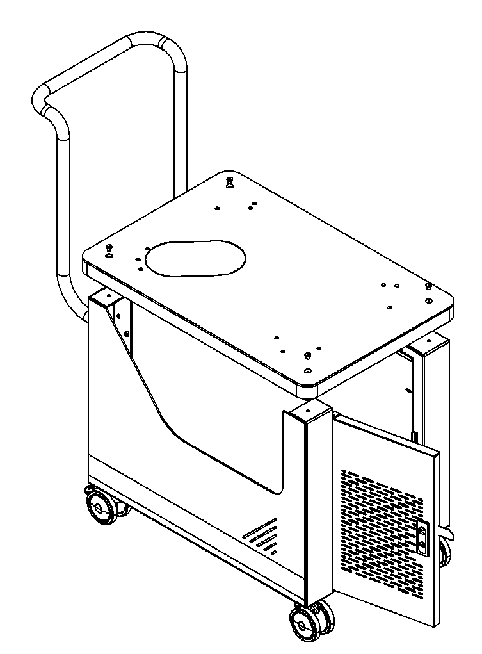 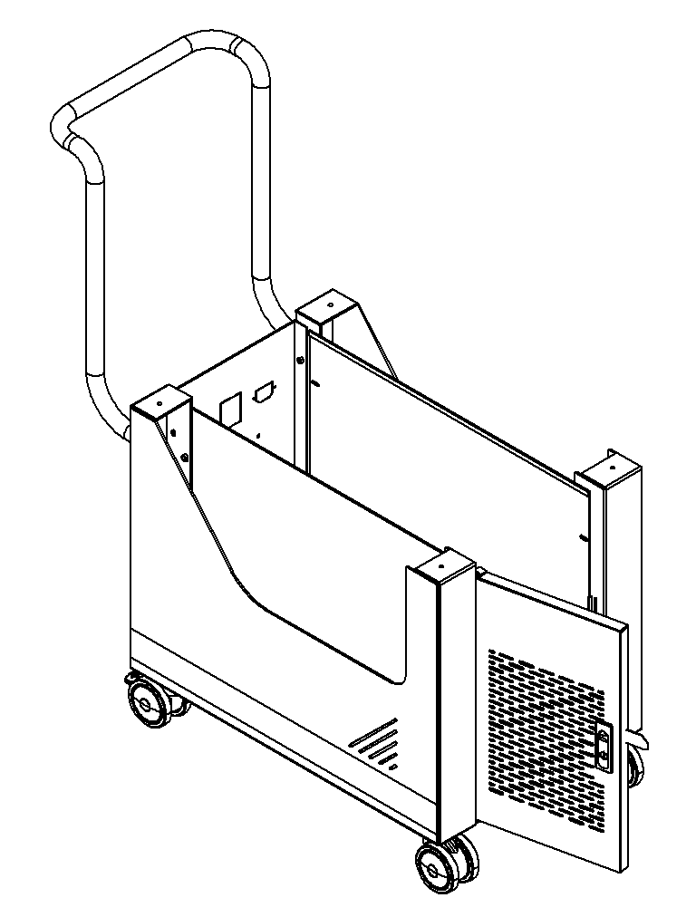

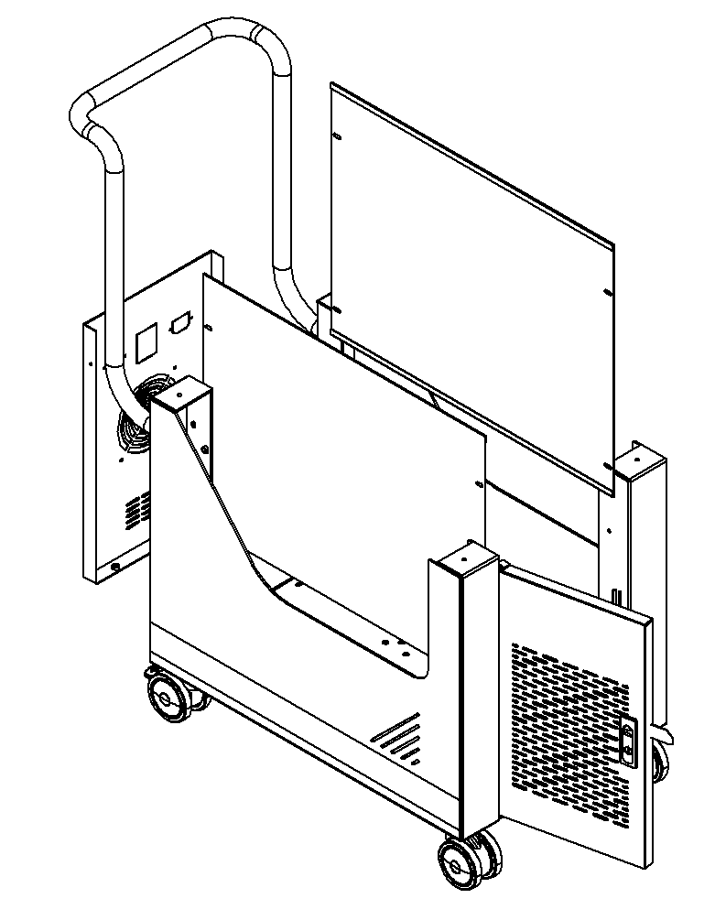 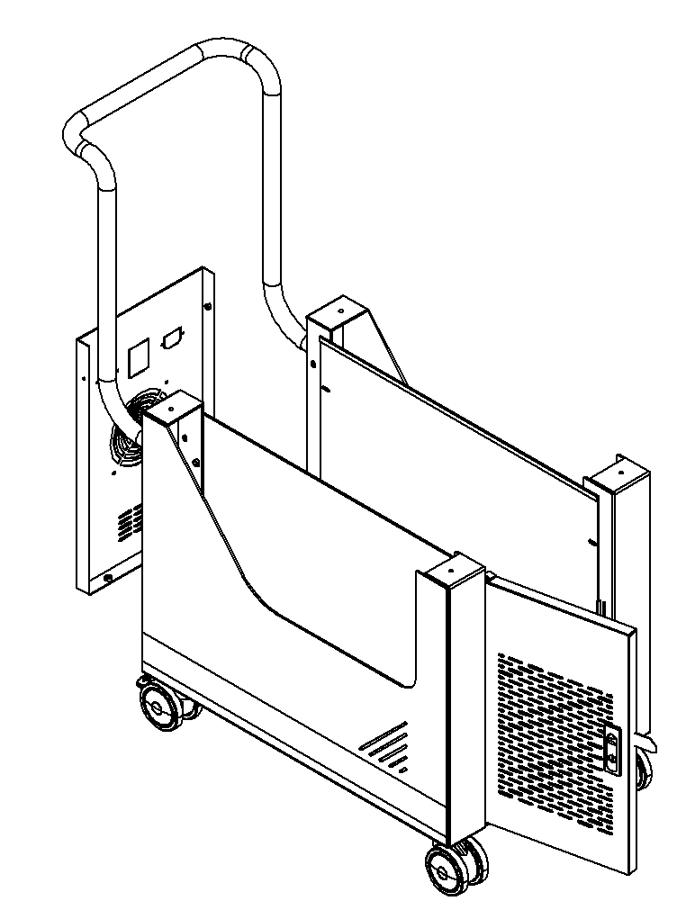

**Machine Components**

|  |  |  |  |  |
| --- | --- | --- | --- | --- |
| No | Description | Specification | Quantity | Remark |
| 1 | Power Input Outlet | AC-03/220v | 1 piece |  |
| 2 | Power Output Outlet | AC-06/220v | 1 piece |  |
| 3 | Air Circuit Breaker | 2P/10A /220v | 1 piece |  |
| 4 | air circuit breaker mounting clip | DZ47-2P | 1set |  |
| 5 | Cooling Fan | 12025/220v | 1 set |  |

**Transportation Instructions**

Two people should cooperate to lift the trolley and remove it from the transport pallet.

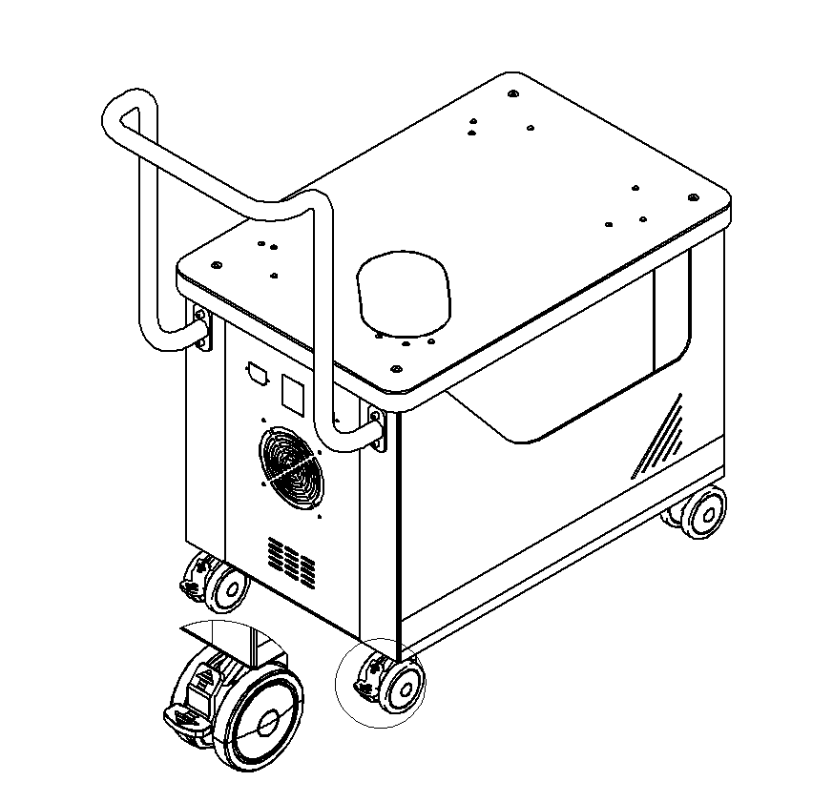

It is strictly forbidden to drag in this direction or in the opposite direction, otherwise it will cause damage to the universal wheel.

Pressing the clip down engages the brake lock, while lifting it releases the lock. The clip must be lifted when moving.

**Shanghai Yiyang Industrial Co., Ltd.**

* 7*24 hours remote technical support
* Phone Number：86+21 5811 0838 86+186211379836
* Website：[www.yiyangindustrial.com](http://www.yiyangindustrial.com)
* Address：Room 302, Building 1, Shuo Gu Kechuang Center, No. 638 Jianyun Road, Pudong New District, Shanghai, China